Searchers Field Trip October 23-24, 2021
Location: Sierra Paloma Claim, Borax Visitor Center and Jasper-Agate Sites
Leader: Margaret Hogarth
Join us on Saturday, October 23, 2021 as we explore the Sierra Paloma Claim for banded travertine onyx. This is an active claim of the Sierra Paloma Rock Club, where anyone may collect so long as they register and deposit info on what they've collected in a tin box to help the club maintain the claim. While you may find some nice pieces of travertine left on the surface from previous collectors, the best pieces require substantial labor. You'll need to dig deep with a shovel and use large gads, chisels, pry bars, and sledgehammers along with thick gloves and eye protection. During a reconnaissance visit on September 29th, we saw that pits had not been dug and worked for some time. Nearly all had significant amounts of earth slumped above the travertine layer. If you really want the good stuff, come prepared to dig deep, and bring rope to haul out any especially large pieces. The rewards are worth the effort. The travertine onyx is beautifully banded black, brown, white, red, yellow, and golden-brown, with some layers showing dendritic patterns. This soft material may be quickly and easily carved, crafted into spheres, and/or slabbed and cabbed to a fine polish. Have a rock hammer and water bottle to evaluate the pieces you find. Much of it has a drab tan crust, but knocking an edge off a corner can reveal colorful bands beneath.
After our lunch in the field, we will visit the Borax Visitor Center (masks are required). It is located at 14486 Borax Road, Boron, CA 93516. If we have time on Saturday afternoon, we will explore nearby jasper-agate sites.
For those who wish to, a group might go to a nearby restaurant in Boron for dinner Saturday night.
Saturday and Sunday, meet at 8:30 a.m. on Clay Mine Road, where the road makes a 90 degree turn. Our campsite is marked with a star on the map, just before Aerial Acres. All vehicles can reach our meeting spot. Most vehicles can make it to the claim site and to the Borax Visitor Center. This is a dry camping site without any amenities. Please bring all food and water that you may need and dress in layers appropriate for the weather.
On Sunday, meet at 8:30 a.m. at our campsite on Clay Mine Road. We will be exploring nearby jasper-agate sites. A high-clearance vehicle is recommended.
Recommended equipment: Rock pick, gloves, shovel, large gads, chisels, pry bars, sledgehammers, rock bag, and spray bottle.
Directions: Proceed to the 15 freeway north. Pass the Cajon pass. Take exit 141 to Highway 395 north. Proceed to Kramer Junction. Take Highway 58 west towards Mojave. Take exit 188, Clay Mine Road, turn right. Proceed about 5 miles and look for the Searchers signs. We will be camping off of Clay Mine Road, before Aerial Acres, where the road makes a 90 degree turn. Our campsite is marked with a star on the map. Allow 2-1/2 hours from Anaheim; it is about 130 miles. For non-campers, there are hotels in California City, Boron, and Barstow.
If you plan to attend, please contact: Margaret Hogarth, hogarth.m@gmail.com, 909-815-3045.
There will not be a potluck on Saturday night, nor will a campfire be allowed.
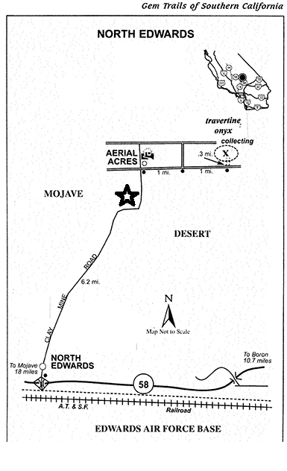
Figure 1 Searchers Campsite near Sierra Paloma Claim.
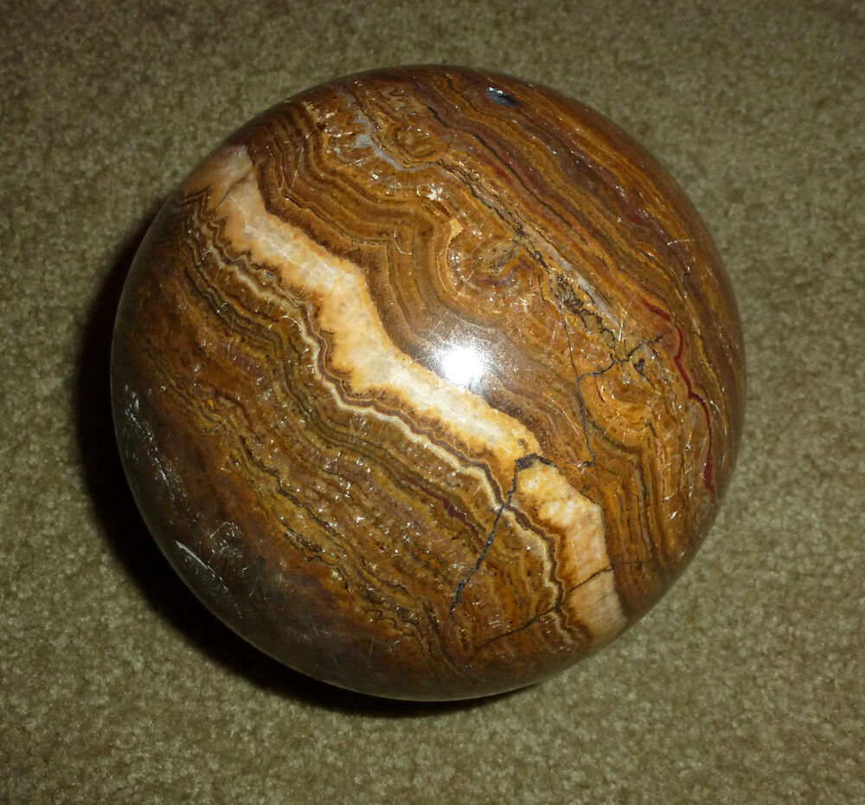
Figure 2 Sierra Paloma Banded Travertine Onyx Sphere by Jim Peterson
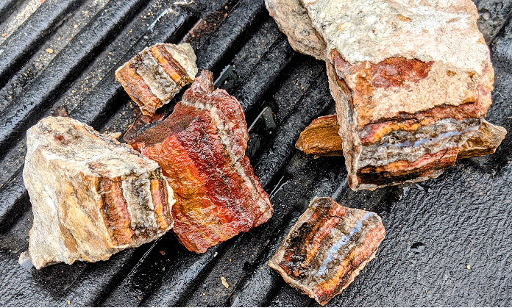
Figure 3 Banded Onxy from Sierra Paloma claim

