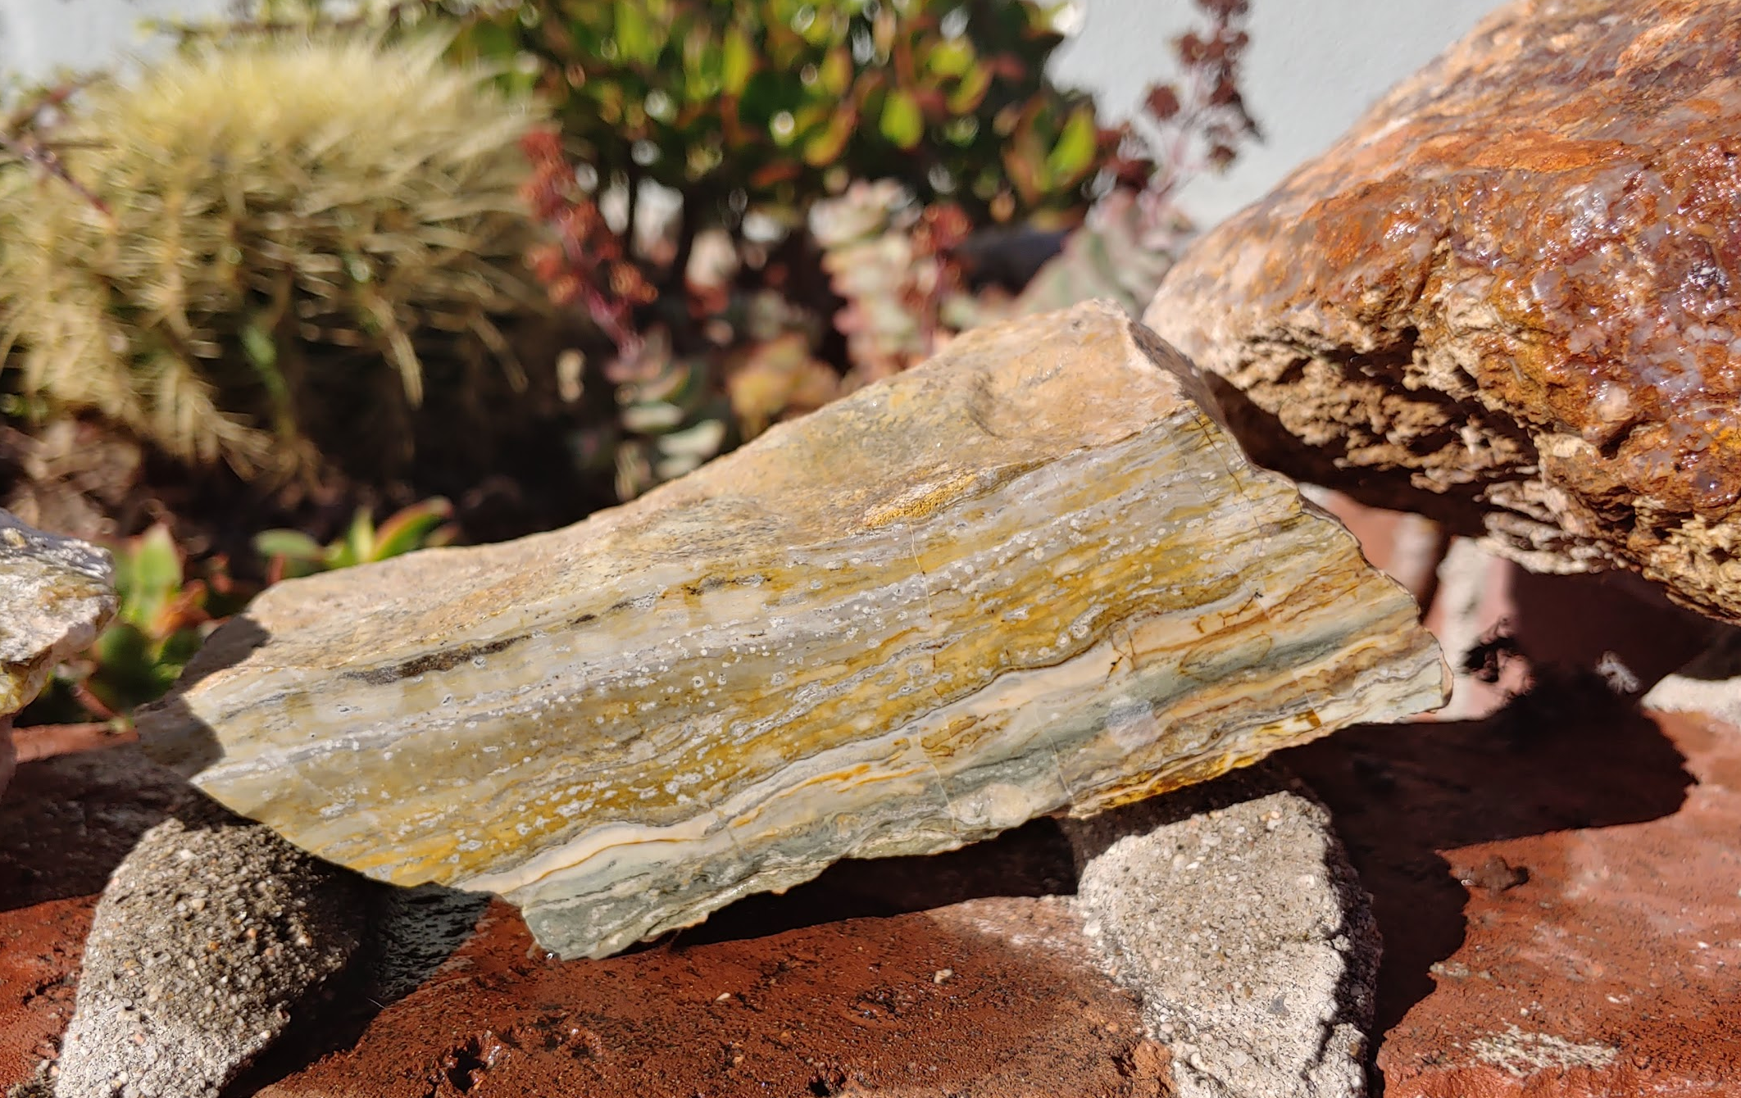
Kramer Hills Field Trip
Saturday, December 14. 2019
Meet 8:30am, Depart: 9:00am
Leader: Andrew Bloxom (vehicle: Black Toyota Tacoma)
Cell# (571)-217-9536 (***Please text message only during business hours)
Email: Andrew.Bloxom@gmail.com

The Anaheim Searchers will be heading to Kramer Hills for a December day trip. This area is comprised of a variety of Tertiary geologic units containing agates, jaspers, and petrified palm. We’ll likely visit 2-3 of the collecting sites around the hills including sites with onyx, opal, and the best-known Kee Kay claim for some hard rocking mining of vibrant red jasper and green opalite. There will also be opportunities for plenty of float collecting of colorful chalcedony and unique agates. This trip will involve off road driving, but two wheel drive vehicles with good clearance can be fine in some cases. The meeting point is just off of 395 on Alcudia Road, approx. 25 miles north of Adelanto (the last town you’ll pass heading north on 395). We’ll meet at 8:30am and leave at 9:00. I hope you all can join!

