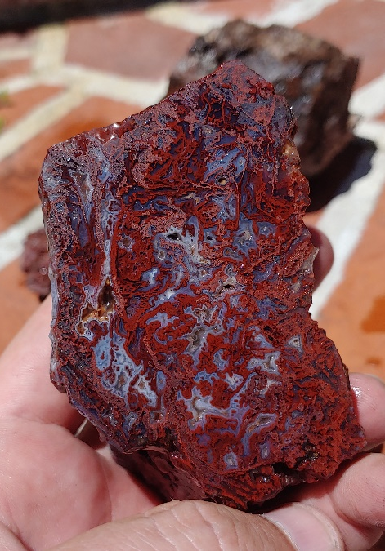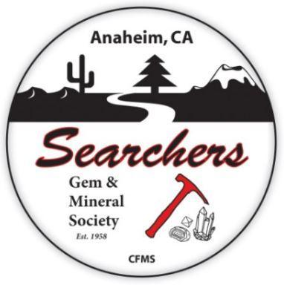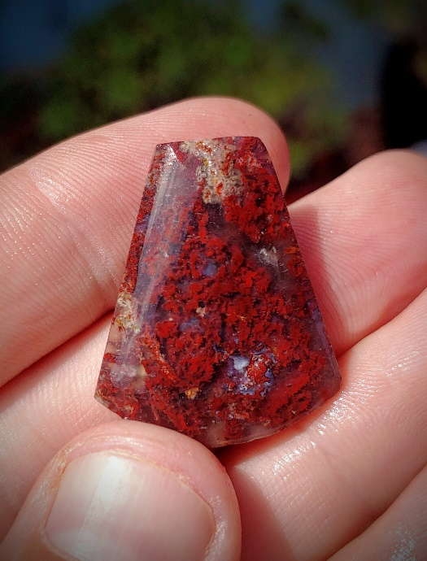
South Cady Field Trip
October 31, 2020
Meet 8:30am, Depart: 9:00am
Leader: Andrew Bloxom (vehicle: Black 2002 Toyota Tacoma)
Cell# (571)-217-9536 (***Please text message only during business hours)
Email: Andrew.Bloxom@gmail.com

The Anaheim Searchers will be to the South Cady Mountains region of I-40 on Halloween for a day of collecting moss agate and jasp-agates in an array of spooky red hues that would make even Dracula’s eyes widen. We’ll collect at 2-3 different collecting locations. This area has been a popular rockhounding locale for decades but still produces some fine quality material. The trails here are rather rough, and 4x4 is recommended, but some 2wd high clearance vehicles could be acceptable. If you want to stick around for Sunday, I will be camping and would be interested to explore some new territory where 4x4 is required. This location is slightly remote (not sure what food Ludlow has open right now) so it makes sense to pack food for lunch and bring plenty of water.

This will be our first trip since COVID-19 began. The Searcher’s board feels that our hobby in particular is well suited to social distancing and nothing about being in the desert makes it difficult to follow the current guidelines and restrictions. With that said, we’ll forgo some of the typical field trip traditions like a group camp and potluck dinner around the bonfire. If you’d like to camp amongst yourselves, feel free to do so, we’re just going to keep the club out of that planning. Please bring a mask and wear it if/when we are in a close group talking. We should be fortunate to be able to resume our group activity in this way and make sure we do everything possible to make it successful and recurrent.

Directions from Barstow, CA (see attached image). We will meet at Lavic Rd., right at the sharp turn where Rt-66 turns left over I-40 toward Sleeping Beauty Mountain.
