**Nugget says, “AU you should come to the meeting. It’s gonna be AU-some!”**



**Thar be GOLD**

**in that thar meetin’!**

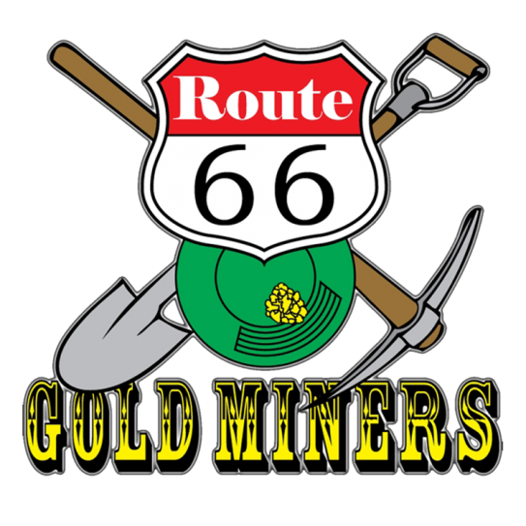

**The Route 66 Gold Miners** will be our guests this month, sharing their passion for gold prospecting & treasure hunting. They will inform us about several topics including: prospecting, panning, and metal detecting.

Much like The Searchers, they care about the right to access public lands and to keep them open to the public for everyone to enjoy. To that end, Route 66 Gold Miners actively support the Gold Prospectors Association of America (GPAA) and the American Mining Rights Association (AMRA).

**Please remember to bring a rock or slab for the Veterans!**